PHASE 4
Testing Document

Programming Project: Database Control with Java

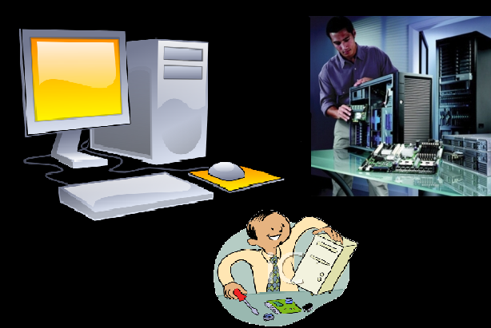

Developed by Jason Chalom 11S

Signoffs
Phase | Teacher | Date | Signature
4) Testing document | Mrs. de Wet

Contents
Fulfillment of features: 3
Specifications of Program Functions 3
Testing data: 4
Appendix A (Test if there will be an error message): 5

Fulfillment of features:

Feature | Yes | No | Mostly

Specifications of Program Functions
- Is the program user-friendly and have an easy to use user-interface? | √
- Can the program exit once it has been opened? | √
- Is the Program able to display error messages if an error occurs when opening the database? | √
- Is the program able to display a message if it is functioning correctly and has successfully opened the database? | √
- Does the program have an about box? | √
- Does the program use queries to display the data from the database? | √
- Is the program able to show the sales data from each table in the database? | √
- Can the program show the items which are returned the most from the database? | √
- Does the program show the amount of money lost by the business from returns of stock? | √

Testing data:
≪In this table you must describe all the things you are testing for. Your focus is to ensure that the program fulfils your specifications as set out in the Project Specifications document. Make sure that you plan the testing before you actually do the program! Use a big variety of data to test. ≫screenshots remove table
Description of what is tested | Testing data | Results
Is the program user-friendly and have an easy to use user-interface? | Ask someone else to navigate through the program and ask that person if they find it easy to navigate and use. Make sure all the action listeners work correctly. | The beta tester said the program was easy to use and therefore is user-friendly. She also said that all the menu items function in the program and all the action listeners work.
Can the program exit? | The Quit Option must be selected. IF it works the application will exit. If it does not work the application will do nothing.  Action Listener - click | The application exited
Is the Program able to display error messages if an error occurs when opening the database? | Take the database file out of the folder where the program is so that it cannot find the database. | The application sent an error message to the user.  (See Appendix A)
Is the program able to display a message in the console if it is functioning correctly and has successfully opened the database? | Run the application and see if the message comes up. | The application does send a message to the user if the database is successfully opened.  (See Appendix B)
Does the program have an about box? | Run the application, navigate to the help drop down menu and click on the about menu option. If it opens an about box then the application has an about box. | An about box opens when the about menu option has been clicked.  (See Appendix C)

Does the program use queries to display the data from the database? | Look at the source code and see if SQL has been used. | SQL Has been used so queries have been used to display data from the database in the application.  (See Appendix D)
Is the program able to show the sales data from each table in the database? | Navigate to the File menu, then the database tasks menu and select “Show Sales Data”. If it is displayed in the Text Area then the program is able to show sales data from the database. | There is sales data shown in the Text Area  (See Appendix E)
Can the program show the items which are returned the most from the database? | Navigate to the File menu, then the database tasks menu and select “Show Which Items are Returned The Most”. If it is displayed in the Text Area then the program is able to show the items which are returned the most from the database. | The program displays the items which have been returned the most and their relevant data in the Text Area.  (See Appendix F)
Does the program show the amount of money lost by the business from returns of stock? | Navigate to the File menu, then the database tasks menu and select “Show How Much is Lost By Returns”. If it is displayed in the Text Area then the program is able to show the amount of money lost by the business from returns of stock. | The amount of money lost by each item is shown in the text area with the relevant information about each item from the Database.  (See Appendix G)

Appendix A (Test if there will be an error message):
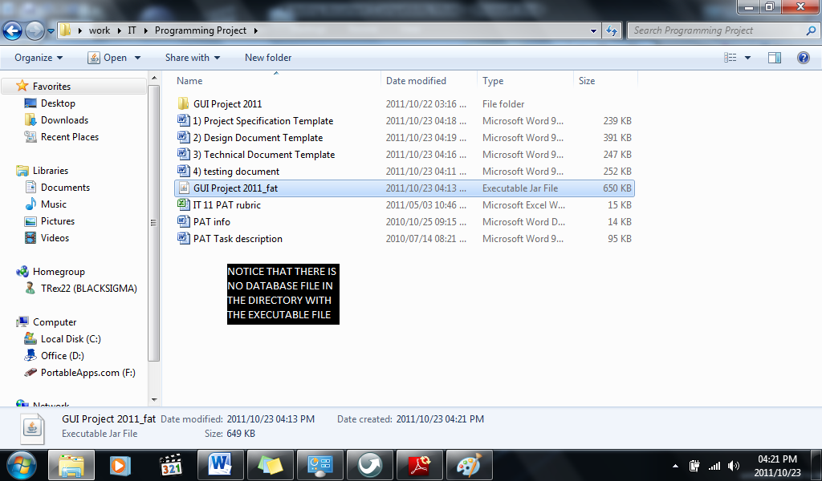

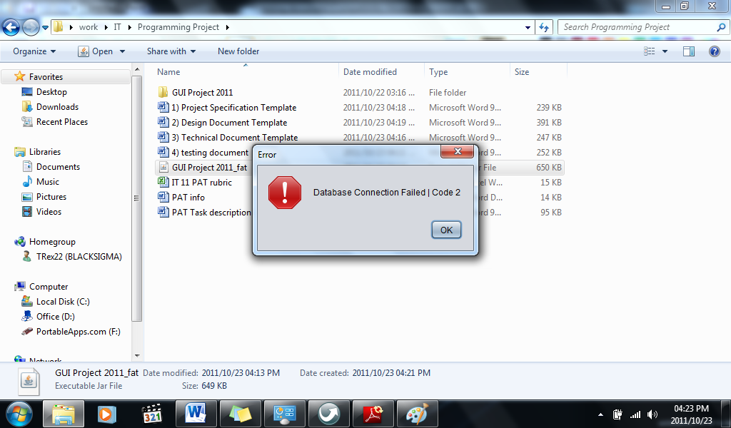

Appendix B (Test if the application sends a message to the user if it successfully opens the database)

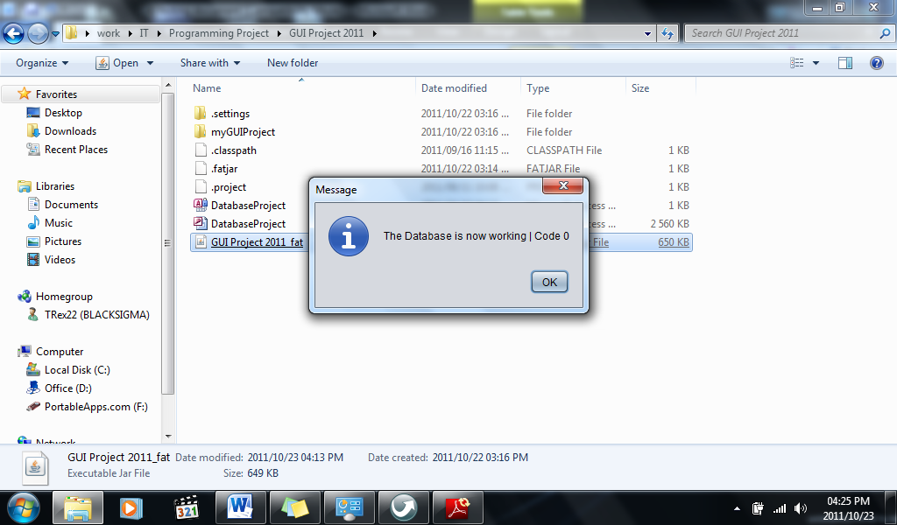

Appendix C (Test to see if the program has an about box)
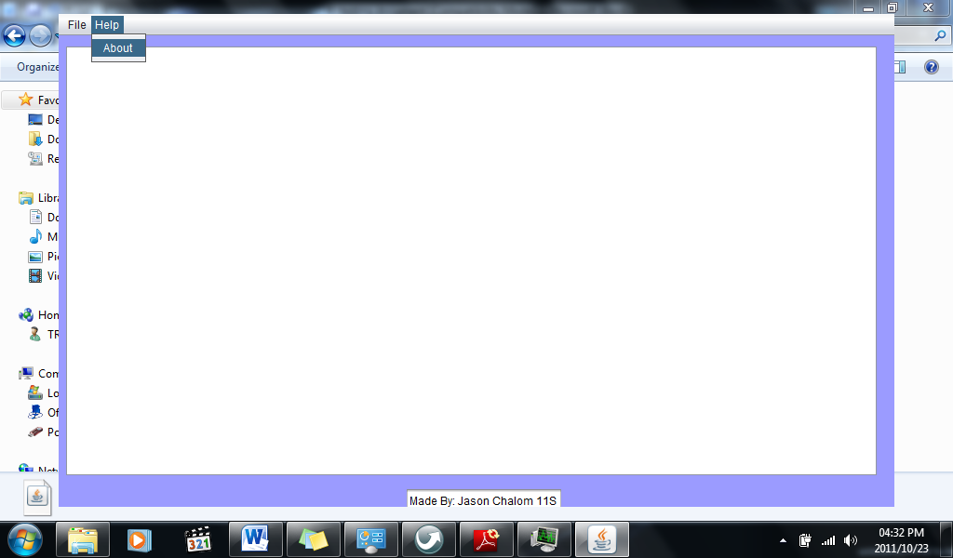

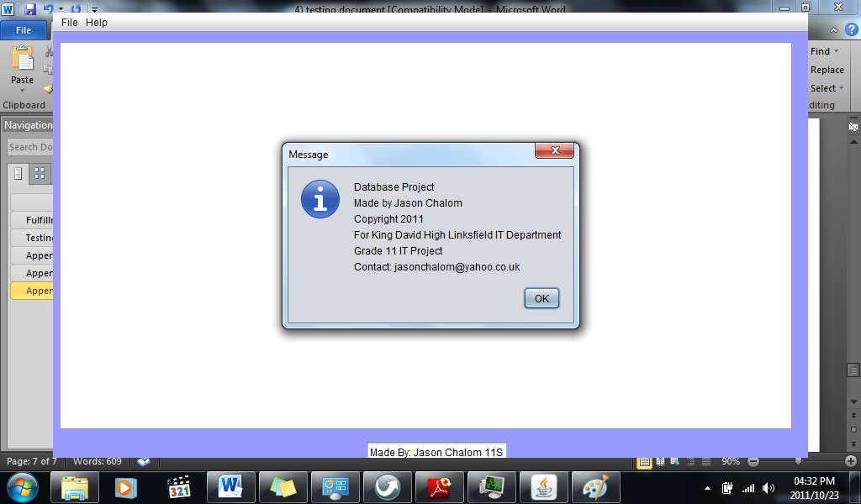

Appendix D (Test to see if queries have been used in the source code)
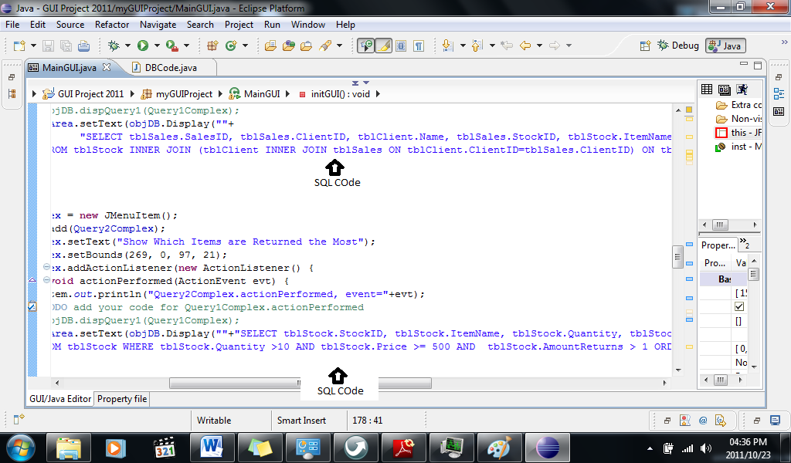

Appendix E (Test to see if the application can show sale data from database)
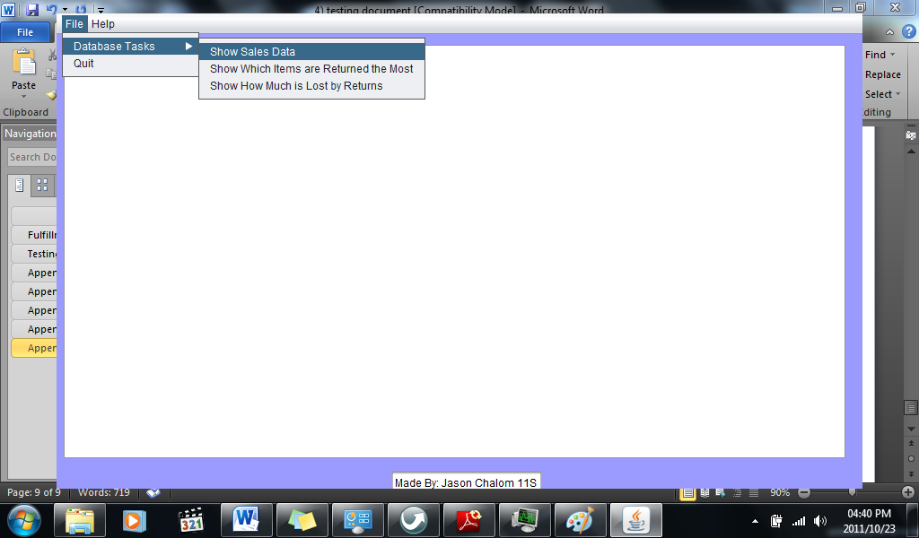
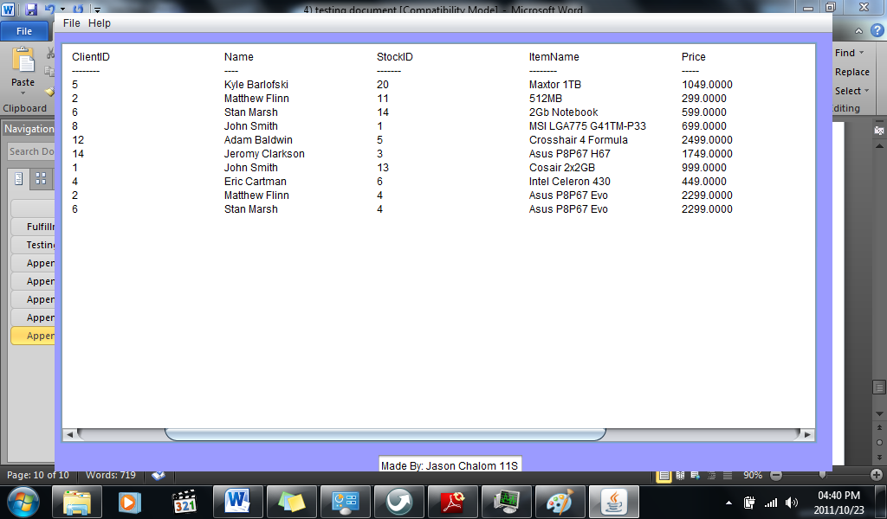

Appendix F (Test to see if the application can show the items returned the most from the database)
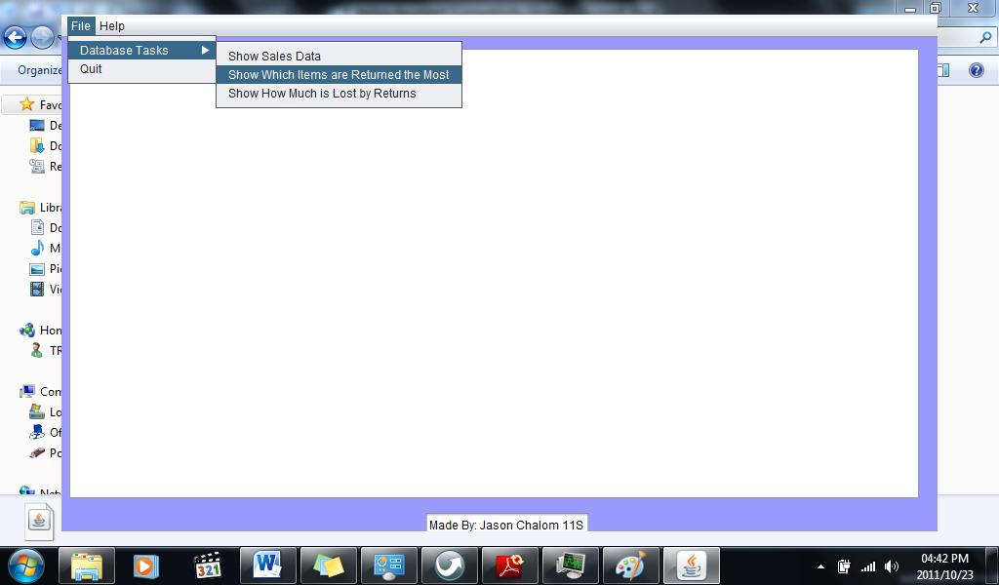
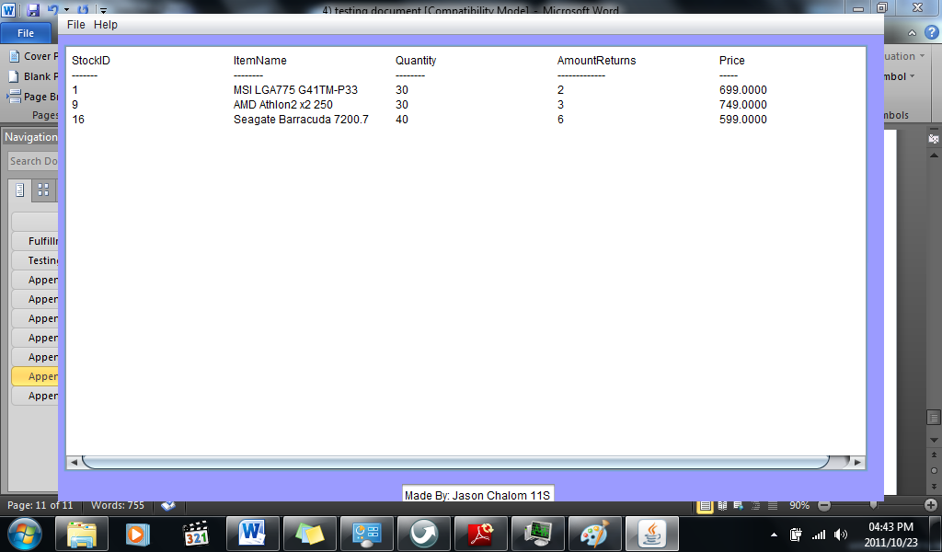

Appendix G (Test to see if the application can show the amount of money lost due to returns)

